**Tide Gauge Brief Description**

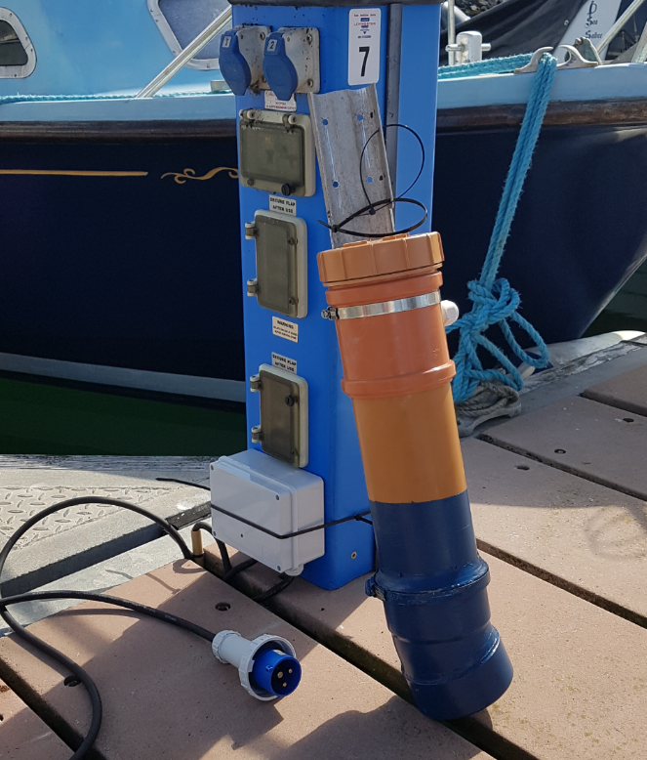The equipment is housed within a fully waterproof and submersible section of 100mm PVC pipe and fittings (Fig 1). This is mounted securely to a marina pontoon in a part of the marina subject to minimum human disturbance or wave action (Fig 2). The device records water depth continuously and writes to a text file on an SD card which is removed periodically and the data copied to PC for processing.

Figure Tide gauge before installation

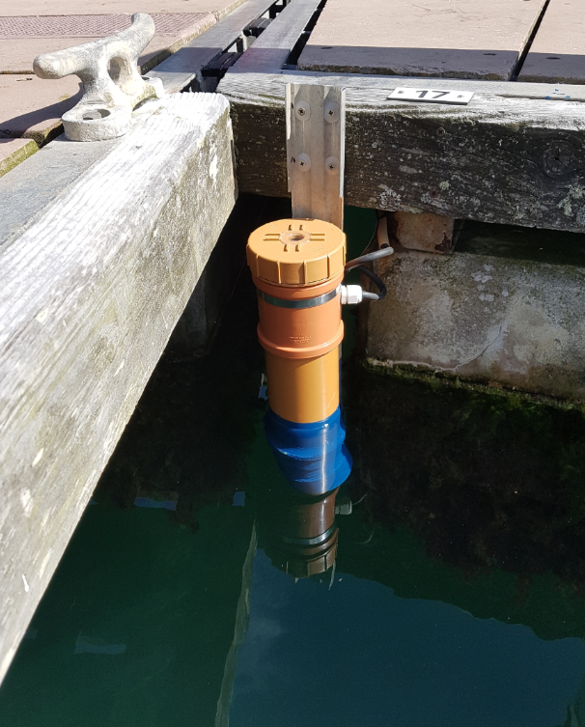

Figure Tide gauge mounted. Note window in lid to view led indicator

At the bottom of the pipe is a Garmin Intelliducer, which is a self-contained depth sounder. Note that this is mounted at an angle of 15 degrees to the horizontal to match the requirements of the transducer. It is designed to be fitted to the sloping hull (dead rise) of a boat. Every two seconds, the sounder outputs an RS232 signal giving the depth of water under the sounder as an NMEA sentence. Above the transducer is a specially designed logger consisting of an Arduino Mega, a GPS shield (module) and a SD card reader/writer shield.

The Arduino software monitors the NMEA 0183 output from the GPS and the Garmin transducer and combines them, thus generating NMEA data every two seconds consisting of the position, date, time and depth of water. The NMEA data are checked for validity and recorded on SD card.

To use this device into a tide gauge, it is mounted in a non-busy corner of the pontoon of Kilmore Quay marina where it monitors the rise and fall of the pontoon and hence the tide. To calibrate the device to Ordnance Datum; the water level at many different tide states was directly measured by a County Council surveyor according to OS datum. He supplied ten measurements, each taken in triplicate. Then, by relating the surveyed levels of the water surface with the depth of water at the exact same dates and times using linear regression, the tide level may be deduced from the recorded depth on a continuous basis.

Fig 3 is a block diagram of how the electronic subsystems are connected together.

Fig 4 is a graph showing tide level (arbitrary datum) measured in the first two weeks of operation in purple, superimposed on the tidal graph for Baginbun (green) and the tide times and HW height for Gt Saltee for the same period (red).

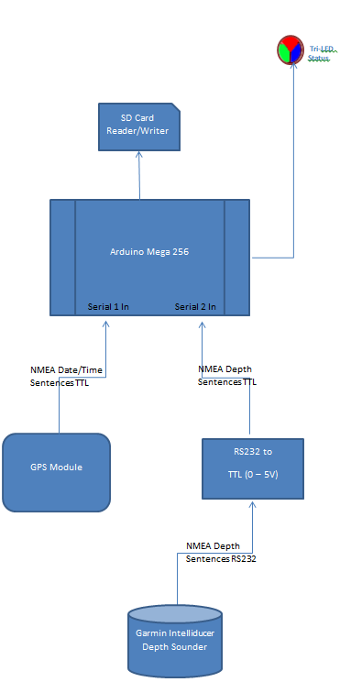

Figure Block diagram of the tide gauge operations

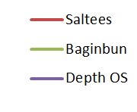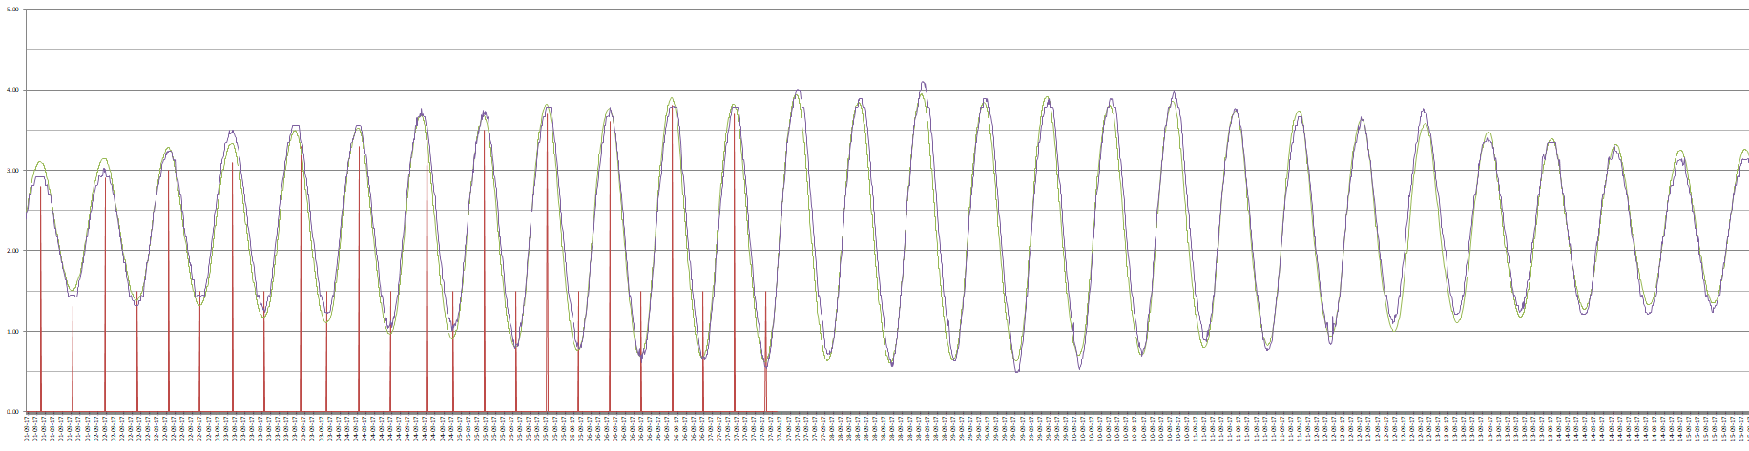

Figure Tide graph for first two weeks